**Service module:**

* Controls services on remote hosts. Supported init systems include BSD init, OpenRC, SysV, Solaris SMF, systemd, upstart.
* For Windows targets, use the win_service module instead

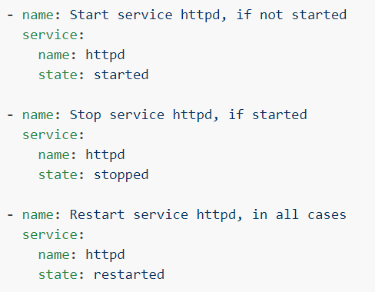

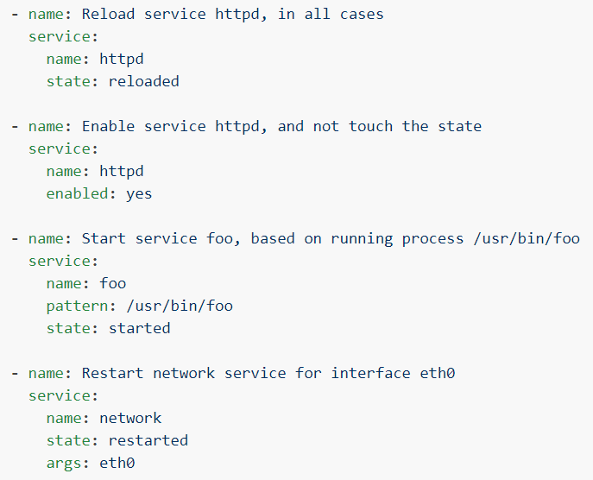

**Options:**

**enabled**

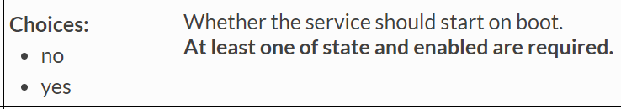

If we enable, service will be started automatically when node gets restarted.

**state**

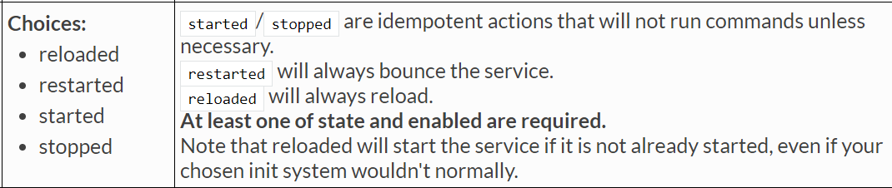

**Get_url module:**

* Downloads files from HTTP, HTTPS, or FTP to the remote server. The remote server must have direct access to the remote resource.
* By default, if an environment variable <protocol>_proxy is set on the target host, requests will be sent through that proxy. This behaviour can be overridden by setting a variable for this task (see setting the environment), or by using the use_proxy option.
* HTTP redirects can redirect from HTTP to HTTPS so you should be sure that your proxy environment for both protocols is correct.
* From Ansible 2.4 when run with --check, it will do a HEAD request to validate the URL but will not download the entire file or verify it against hashes.
* For Windows targets, use the win_get_url module instead

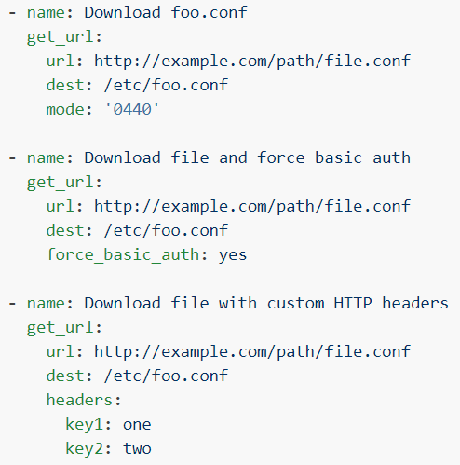

**Options:**

**“owner”, “group” & “mode”** options are available here also.

**backup**



**dest**

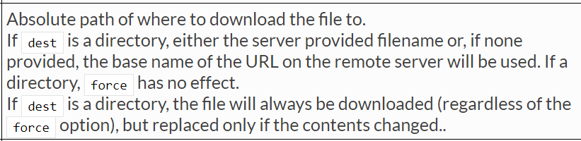

**force**

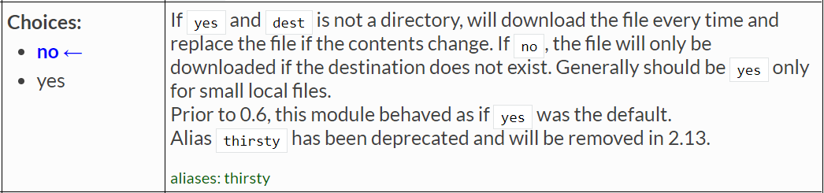

* If the option is set to yes, then it will forcefully replace the file in destination if the file already exists. This will be applicable only if the content is changed in the file.
* Otherwise, it will just ignore if the file already exists.

**url**

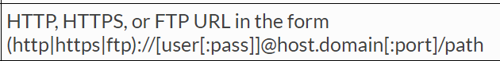

**url_username**

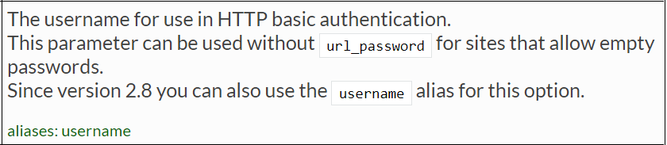

**url_password**

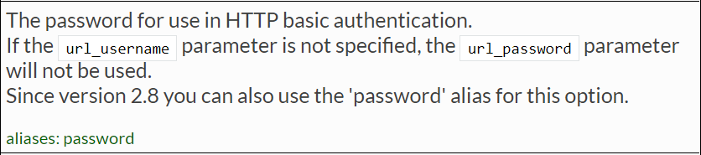

**use_proxy**

